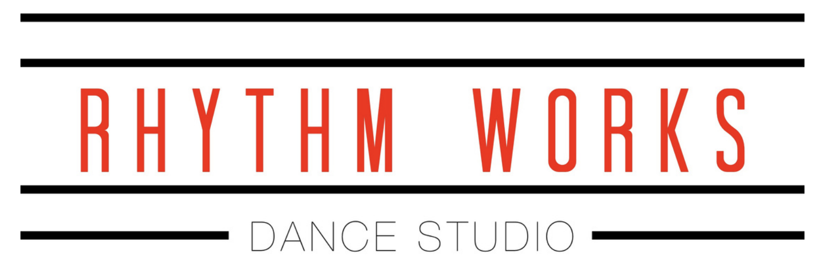

**RW Commitment form 2024-2025**

This is an outline of my expectations and request for your commitment. Please

carefully read and initial each line as each will be strictly enforced.

**GENERAL:**

____ All communication will be given via email and text. I will check for updates often.

____ Enrollment in our autopay system is required for all tuition charges. Full payment is due by the 10th of each month. If the card is declined we will contact you. Payment not received by the 10th of the month will be an automatic late fee of $15.

____Autopay only includes tuition. I understand that I am responsible to pay for all other balances on time in the office via credit card ($5 processing fee will be charged), cash or check.

____Parents will not be allowed to stay and watch. We will have designated parent watch days. This will allow students to give 100% attention to the teacher and the class.

____ Dancers will not be more than 10 minutes early and will be picked up within 10 minutes of class ending. All staff is attending to classes and cannot watch kids left at the studio. If you will be early or late PLEASE CALL THE OFFICE so dancers can wait with them. Dancers picked up more than 15 minutes late may be charged a waiting fee.

____Rhythm Works has the right to cancel class due to weather, pandemic, increased illness, natural disaster, power outage or attitude unforeseen event. At the time of such events, tuition will not be prorated rather make-up classes will be offered.

____ We do not prorate tuition. All tuition is based on the number of classes per year. I understand that some months will have more classes than others but each team has an equal amount of classes.

____ Rhythm Works follows Davis County School District traditional holiday closures. We will be closed for Labor Day, Fall Break, Thanksgiving Break, Christmas Break, Martin Luther King Day, Presidents Day, Spring Break, and Memorial Day. WE DO NOT CLOSE FOR TEACHER PREP DAYS!

____Rhythm Works has the right to share photographs of dancers (including team, studio class, individual, competitions etc.) for advertising, promotion, social media or website purposes without further permission.

____Dancers that do not drop by the 15th of the month will be charged a full months tuition.

____ If you are having trouble keeping up with teammates, privates will be available at an additional cost.

____ A parent/dancer, teacher/ director conference may be necessary if a dancer is struggling both in attitude and in performance.

**COSTUME AND ATTIRE:**

____Proper dance attire will be worn to each class. DANCERS MUST WEAR ALL BLACK. Bring all shoes to each class! Hair must always be pulled back away from face. Dancers will not be allowed to participate in class until they are wearing proper attire.

-Jazz/turns/leaps class: form fitting clothing with two dance shoes. Hair must be pulled back into a tight ponytail or bun. NO BAGGY CLOTHING WILL BE ALLOWED

-Hip Hop: T-shirts and sweats okay, sneakers, and long pants recommended.

-Ballet: black leotard, pink tights, ballet shoes with hair in a bun. Ballet skirts and leg warmers are permitted. Dancers may wear tights on top of leotard. Pants may be worn as dancers are warming up.

-Acro/ tumbling: leotard or form fitting tank and shorts, barefoot. Hair pulled back tightly.

____There will be no refund on costumes PERIOD.

____If a costume is misplaced or damaged you will be charged the full amount to replace it.

**LATE, ABSENCE and MAKE-UP**

____Any absence excused or not excused is an absence. I will contact the office NOT THE TEACHER to let know of any absence.

____You will be counted LATE if you arrive after the first 10 minutes of class. Please note: 6 lates = 1 Absence 6 Leave Early = 1 Absence

____If you are absent the week of performance you will be spaced out, no questions asked! You will be charged a $50 re-spacing fee per routine.

____ If a dancer is removed from a routine due to injury and or absences, the choreographer and director have the right to decide whether or not the dancer will be spaced back in.

____If a dancer misses more than 4 consecutive technique classes without make-up lessons THEY WILL BE MOVED TO A LESS ADVANCED TEAM and pay a spacing fee. DO NOT BE THE PERSON THAT HOLDS YOUR TEAM BACK!

____ Dancers are permitted 3 absences for each half of the 2024-2025 season if dancing 2 days a week. Dancers are permitted 5 absences for each half of the 2024-2025 season if dancing 3 days a week. This includes choreography and technique classes.

____Dancers are required to make-up technique classes by attending another class or scheduling privates with an assistant/ teacher at additional expense. Dancers that miss choreography will be charged $20 to make up choreography with an assistant OR $10 if multiple dancers attend. TEACHERS WILL NOT BE RETEACHING CHOREOGRAPHY IN CLASS, ONLY A QUICK REVIEW!

____ If you exceed the number of absences and do not take make-up classes, you will be removed from a routine and/or the team.

**DANCERS:**

____I understand that my actions affect all the members of my team. I will practice and commit to work hard at each practice and at home, be a positive example to my teammates, and have a positive attitude.

____ I will not give corrections to other dancers, as that is the teacher's job. Please be respectful!

____ I will strive to be the best I can be both as a dancer and person. I understand my instructors are helping me to achieve my goals.

____ I am committed to being fully part of my team and Rhythm Works Dance for the 2024-2025 dance year. I love to dance and want it to show!!

Parent Signature:_______________________________________________________ Date:___________________

Dancer Name:_____________________________________________________